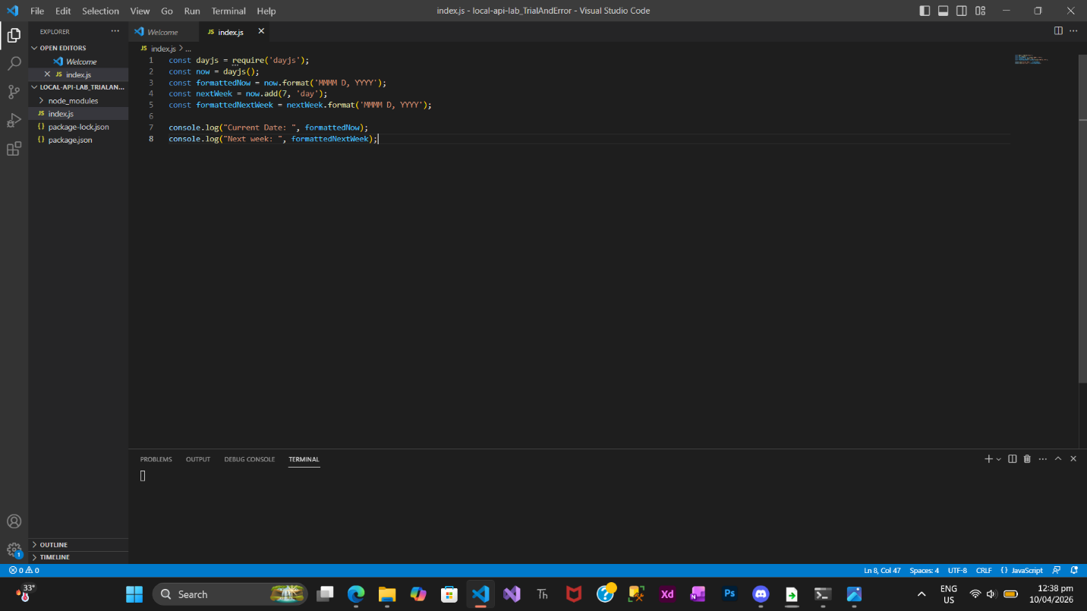
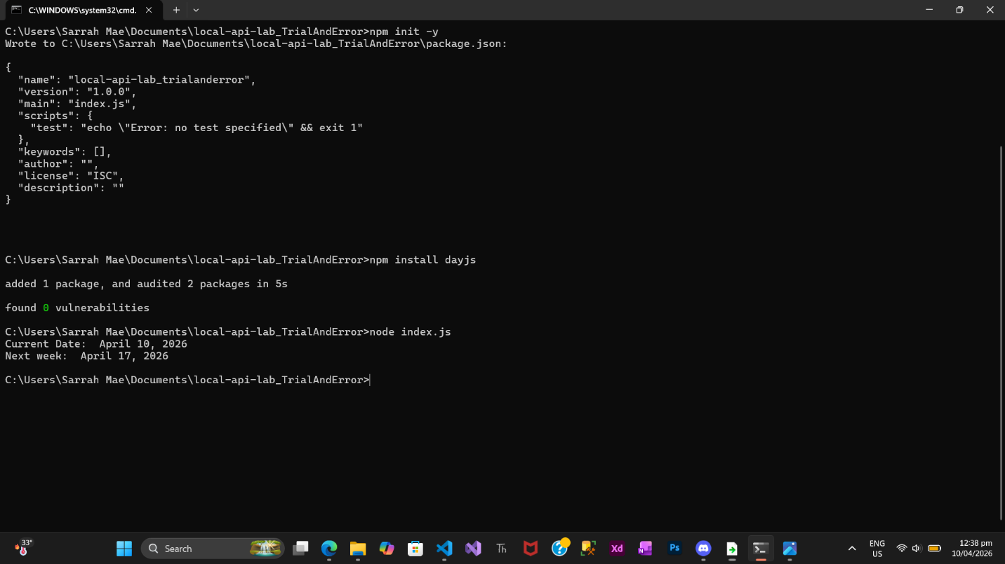

Question:
How does using dayjs demonstrate the concept of "abstraction" compared to writing a function that calculates leap years and days of the month manually?
Using Day.js demonstrates the concept of abstraction because it hides complex date calculations behind simple and easy-to-use functions. Instead of manually writing code to determine leap years or the number of days in each month, the library already handles these rules internally. This allows the programmer to focus on what they want to do with dates, rather than how the calculations are done. In contrast, writing a function manually requires dealing with all calendar rules, making the code longer, more complex, and more prone to errors.

